# pva

Augustus Mendy

Southern New Hampshire University

CS-340-10011-M01

Professor Gebre-Amlark

March 30, 2025

## 4-1 Milestone: Create and Read in Python

1. Upload the Austin Animal Center (AAC) Outcomes data set into MongoDB by **importing a CSV file using the appropriate MongoDB import tool**. This file is in the /usr/local/datasets/ directory in Apporto; the filename is “aac_shelter_outcomes.csv.” Use the database name “AAC” and collection name “animals.” Complete the import using the **mongoimport** tool, and **take screenshots** of both the import command and its execution.  
   **Note:** If you completed the Module Three milestone, you have already completed this step.

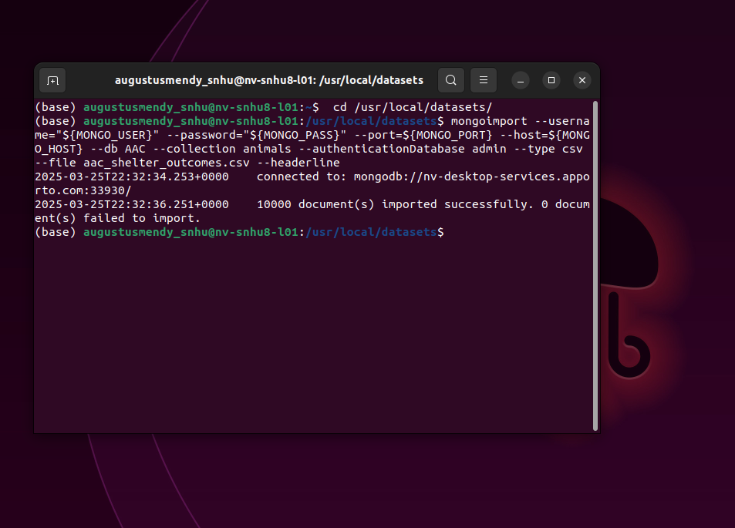

1. Next, you must develop a Python module in a PY file using object-oriented programming methodology to enable **create** and **read** functionality for the database. Other Python scripts must be able to import your Python code as a module to support code reusability.  
   **Develop** a CRUD class that, when instantiated, provides the following functionality:

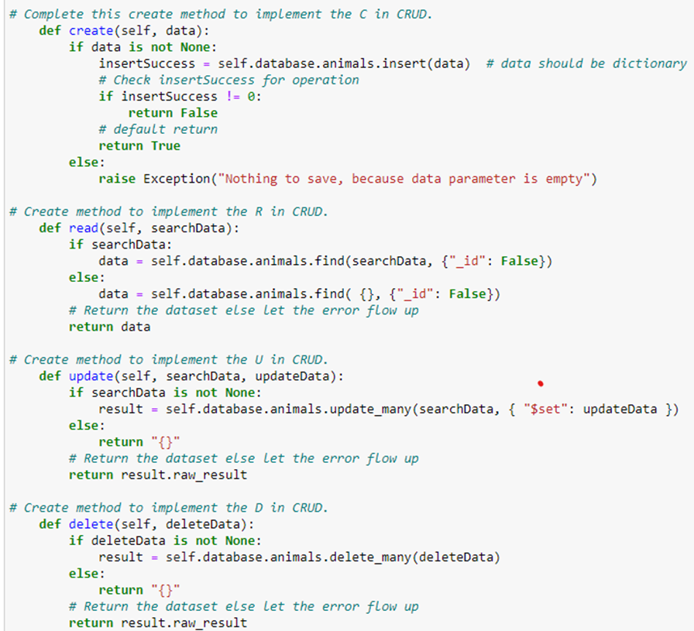

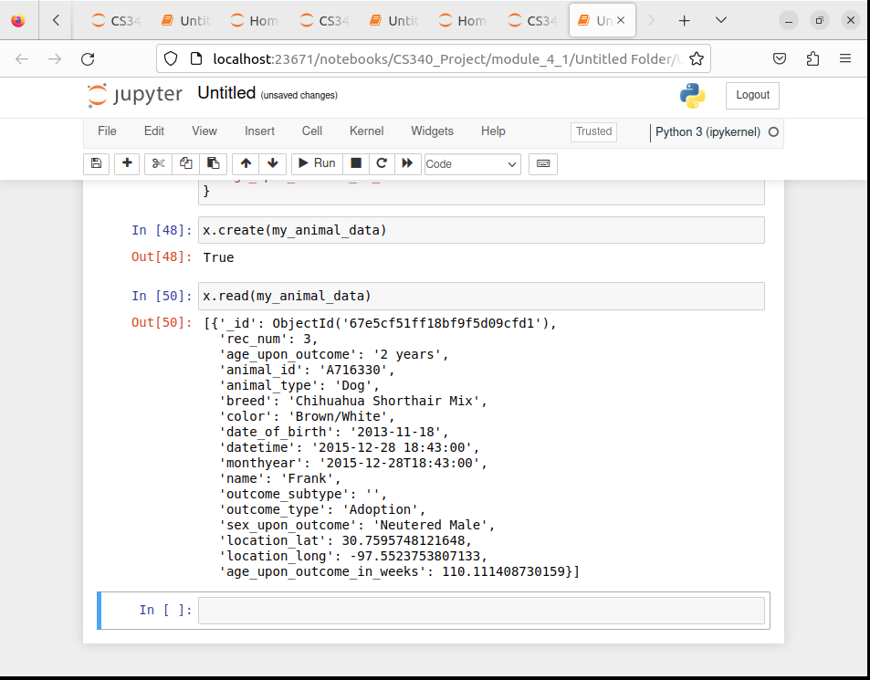

1. Finally, create a Python testing script in Jupyter Notebooks that imports your CRUD Python module to call and test the create and read instances of CRUD functionality. Be sure to use the username and password for the “aacuser” account for authentication when instantiating the class. This script should be created in a separate Jupyter Notebook IPYNB file and should import and instantiate an object from your CRUD library to affect changes in MongoDB. After creating your script, execute it in Jupyter Notebook and take screenshots of the commands and their execution.

